Re-assign the re-published tests if the status is unused

I. Process information 2

A. New testid replacement steps 2

B. Pre-requisites 2

C. Assumptions 2

D. Tables list involved in the process: 2

II. Questions 3

III. Results 3

1. Test collection mismatch: 3

2. Missing testsections 3

3. Process completed successfully 4

# Process information

Goal: If the content information has changed for existing items, we need to re-assign the new version of re-published tests if the student test status is unused.

The test replacement process re-assigns new versions of tests.

## New testid replacement steps

1.  Build a tracking table to find the tests that need a change, and to capture how many student tests were impacted.

2.   Validate test collection to make sure the same test collection is in before and after the change.

3. Inactivate unused student tests and student test sections and test session if the session is related to an old test id.

4. Re-assign student tests, student test section, and test session (if session has testid).

5. If an old test session record has studenttrackerband inactivate the old record and re-assign the new student tracker band with the new test session id.

## Pre-requisites

1.  Testid list from users.

## Assumptions

1.  Test collection should be the same for the old version test and the new version test.

2. Operational test window id is active for the old version test. No other validation check added for this.

## Tables list involved in the process:

|  |  |
| --- | --- |
| Table Name | process |
| studentstests | Update/Insert |
| studentstestsections | Update/Insert |
| testsession | Update/Insert |
| studenttrackerband | Update/Insert |
| testreplacetracking | Insert (new table added to this feature ) |
| select public.assignedtestreplaceprocess() –Proc | |

# Questions

* Test replacement process created to use the **breach** test process.

# Results

### Test collection mismatch:

select testidold,testidnew,status,processerror from testreplacetracking;

|  |  |  |  |
| --- | --- | --- | --- |
| testidold | testidnew | status | processerror |
| 38 | 213 | failed | Mismatch test collection for Old testid:38 collection externalids:10 New testid:213 collection externalids:0 |

#### 

### Missing testsections

select testidold,testidnew,status,processerror from testreplacetracking;

|  |  |  |  |
| --- | --- | --- | --- |
| testidold | testidnew | status | processerror |
| 38 | 213 | failed | testsection are missing for new testid |

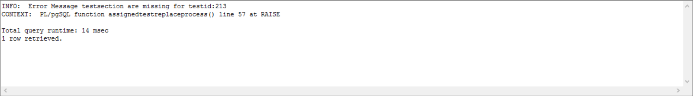

### Process completed successfully

select testidold,testidnew,status,processerror, studentstestsids from testreplacetracking;

|  |  |  |  |  |
| --- | --- | --- | --- | --- |
| testidold | testidnew | status | processerror | studentstestsids |
| 38 | 213 | complete | <NULL> | 173,189 |

